**Task 21: Efficient S3 Bucket Management with AWS LAMBDA: Identify and Remove Empty Buckets**

AWS Lambda is a **serverless compute service** provided by Amazon Web Services (AWS) that enables you to run code without provisioning or managing servers. Lambda automatically scales and executes your code in response to defined triggers, such as HTTP requests, changes in data, or scheduled events.

In modern cloud computing, managing S3 buckets efficiently is crucial for optimizing resources and maintaining a clean infrastructure. With AWS Lambda, we can automate tasks like identifying and removing unused or empty buckets, **ensuring a streamlined and cost-effective storage environment**. This serverless solution not only simplifies bucket management but also eliminates the need for manual intervention.

This task illustrates how lambda function implements to check and delete the empty bucket.

1. **Created a bucket named “bucketwithcontent” And uploaded some file in that bucket in S3**

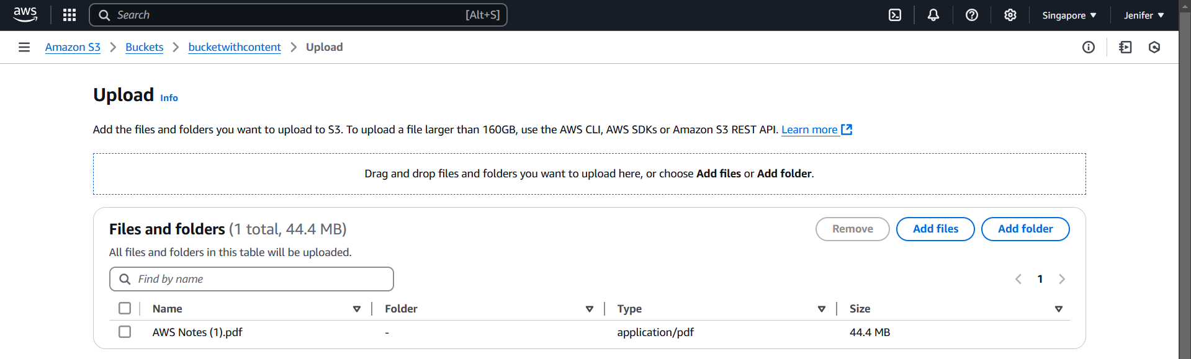

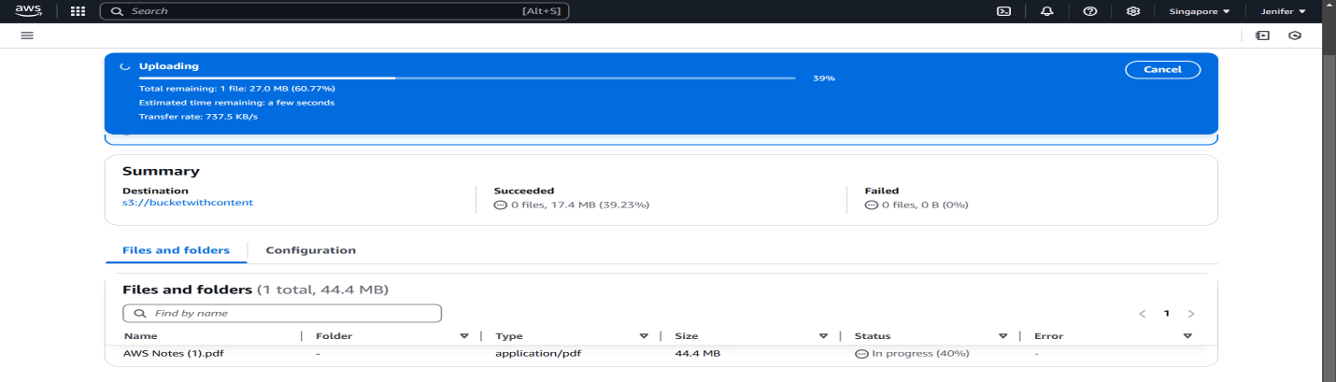

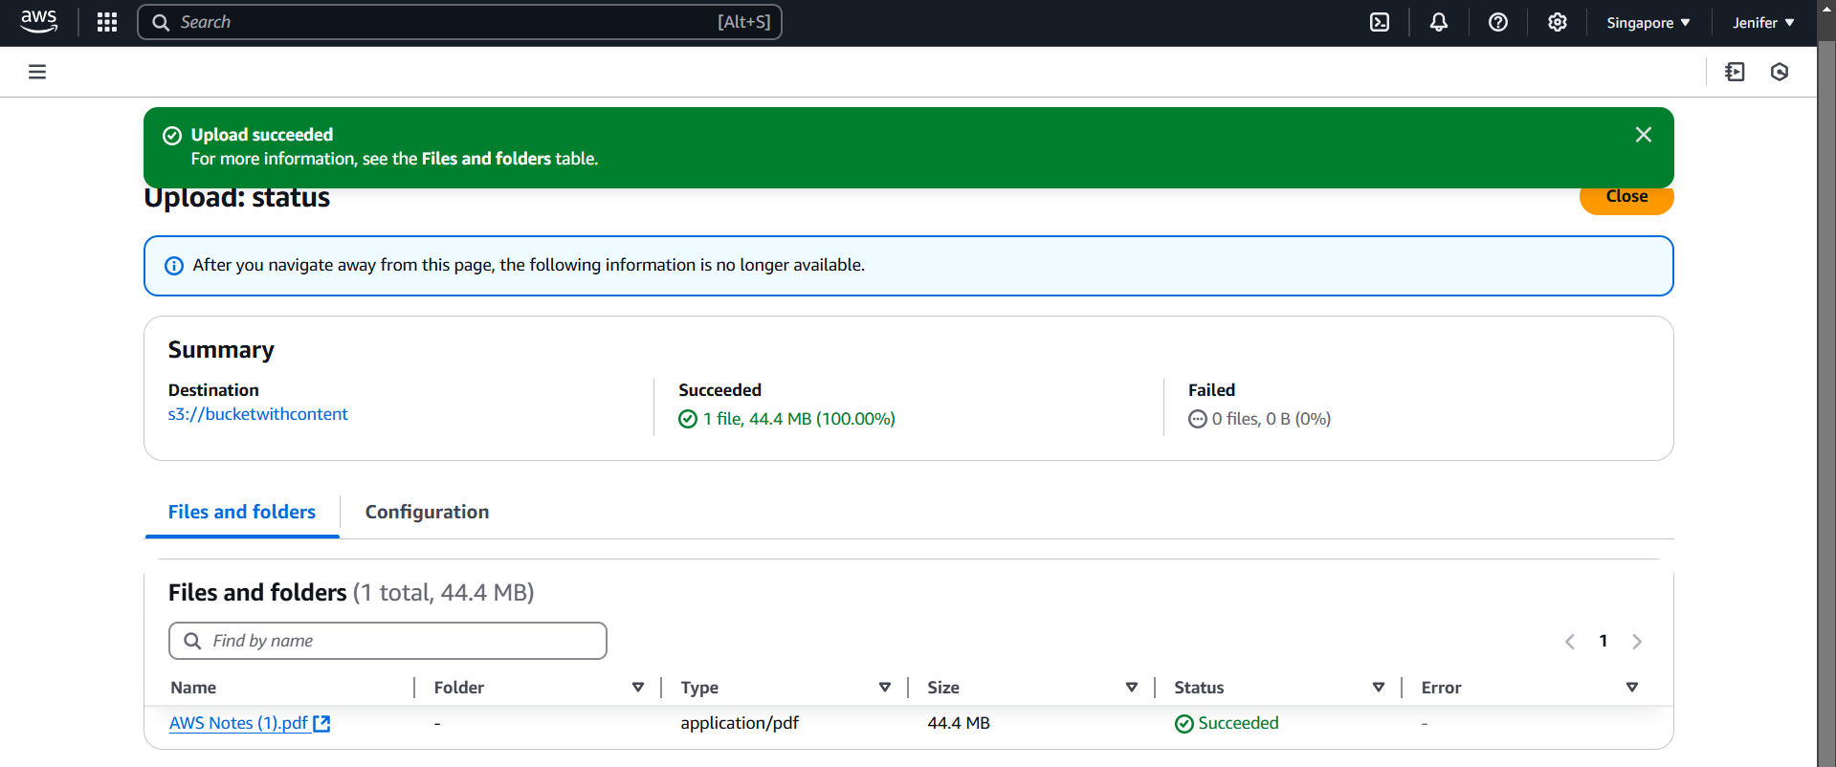

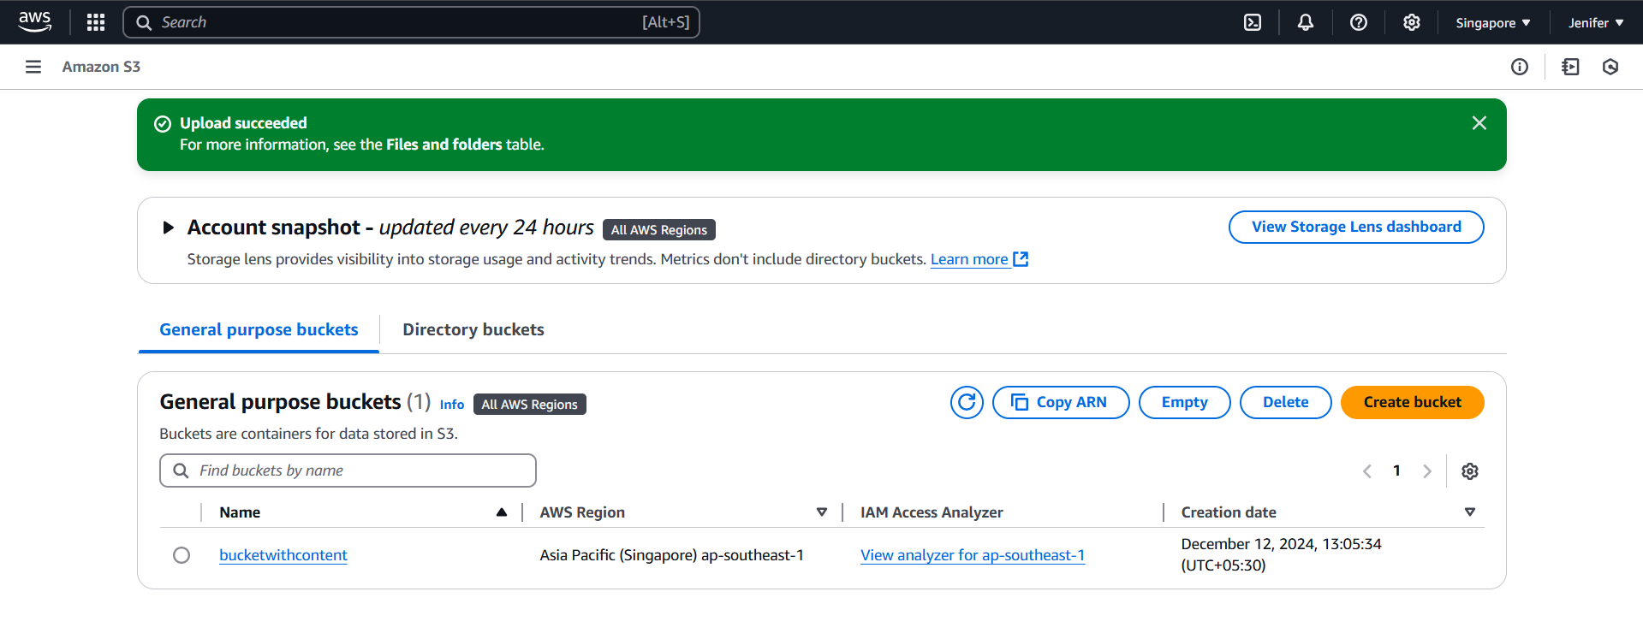

1. **Created 3 Empty Buckets**

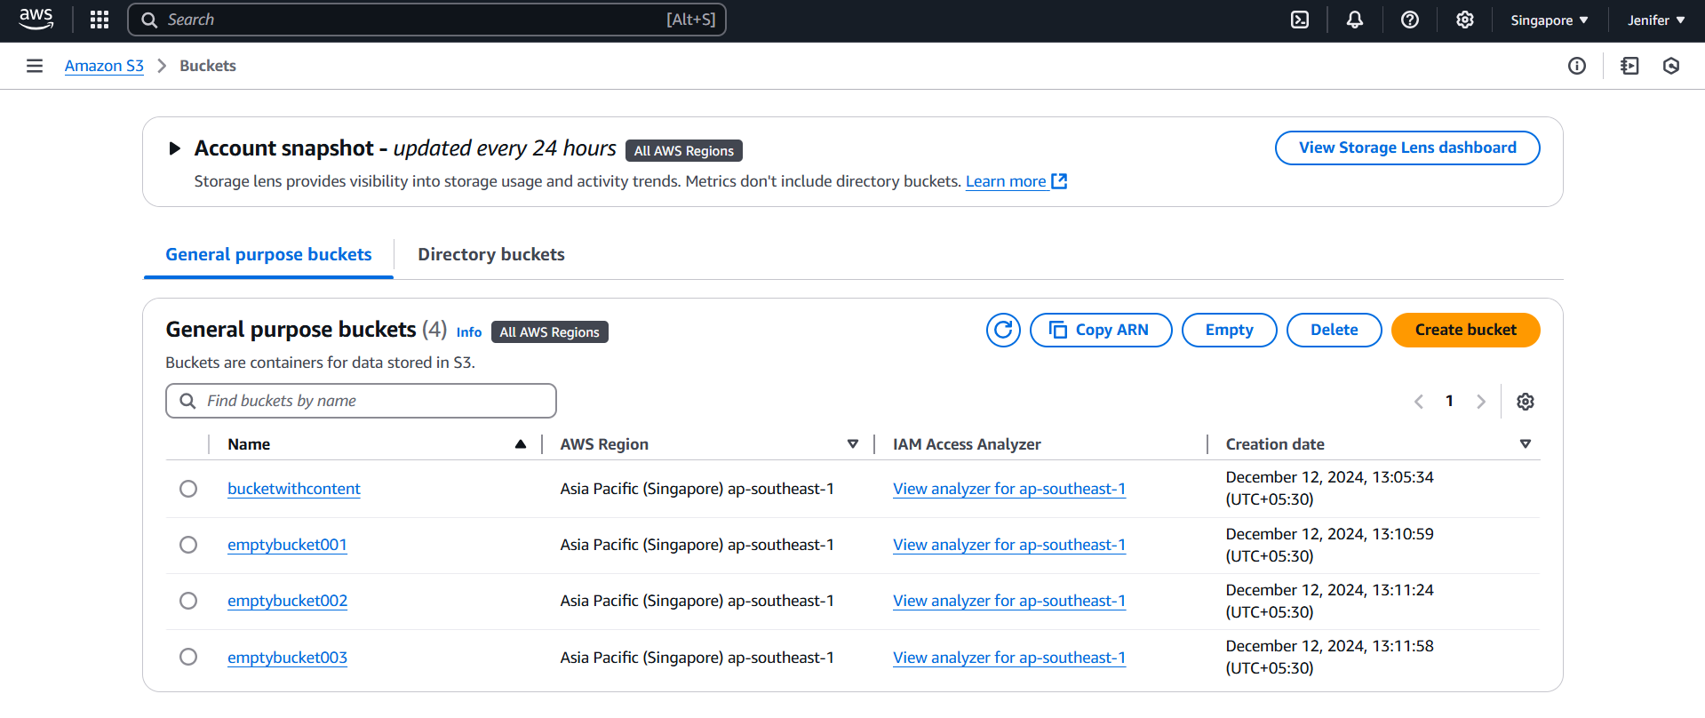

1. **Created a Lambda Function**

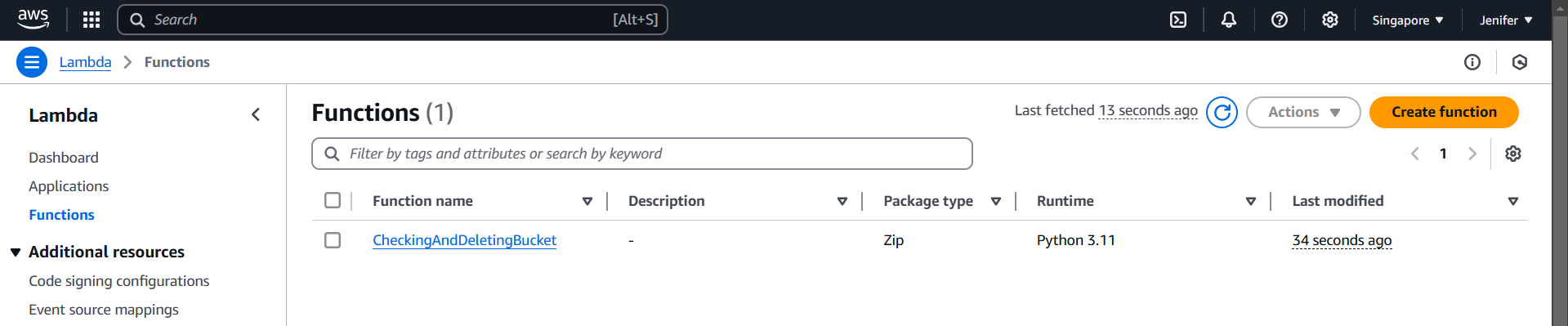

1. **The Code Deployed successfully to Check the bucket list and delete the empty buckets**

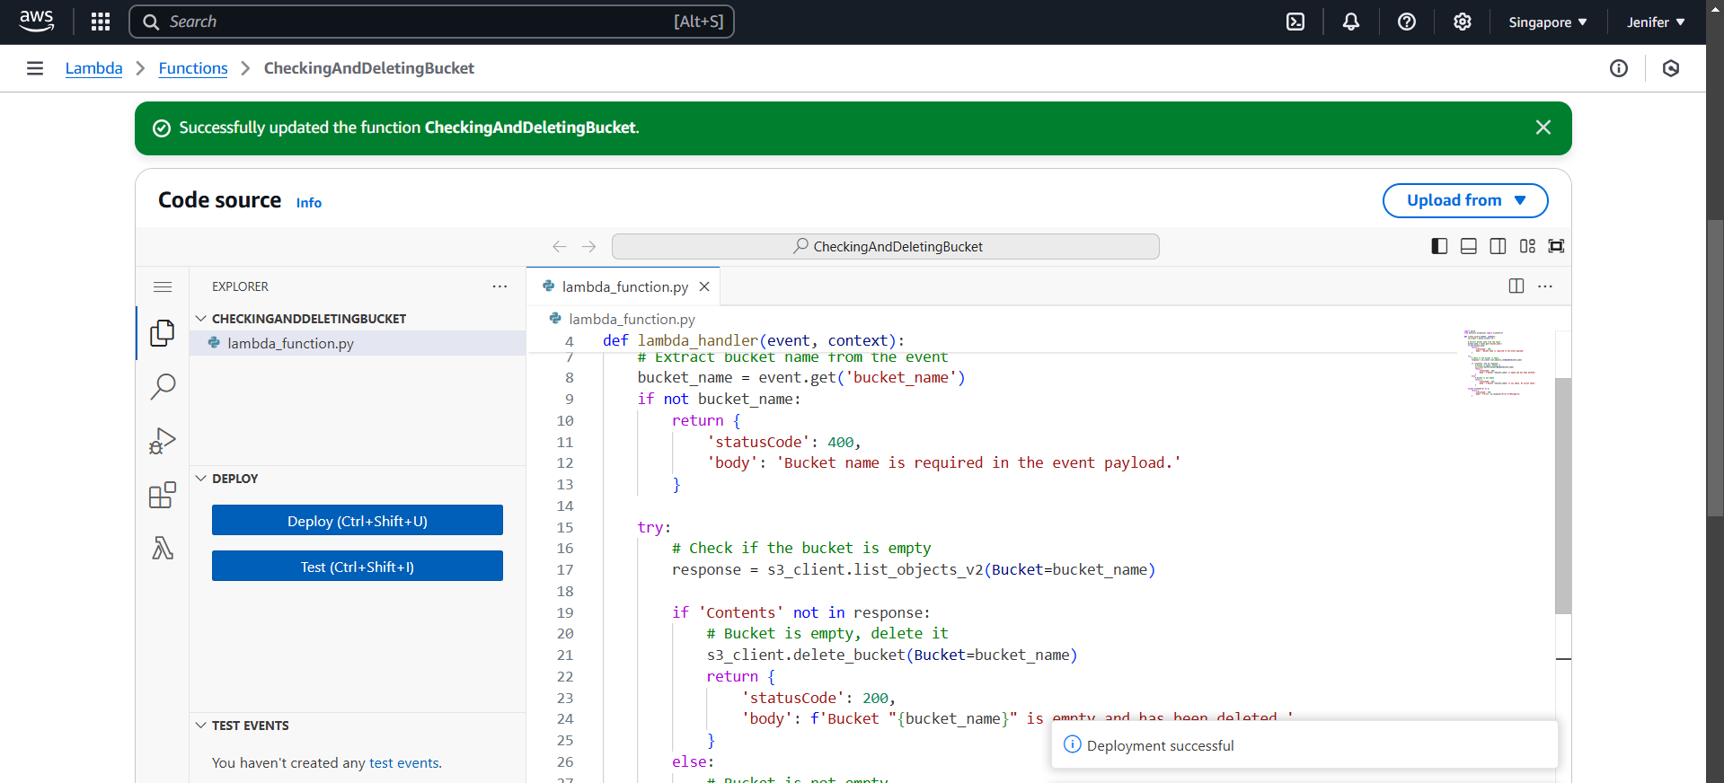

1. **Policies Created for the implementation**

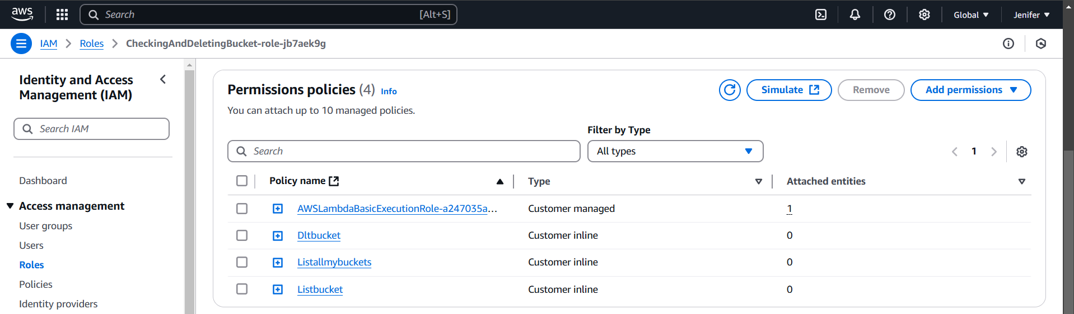

**The needed policies are:**

* **DeleteBucket & ListAllMyBuckets**

1. **Edited the Time out setting in Basic Settings**

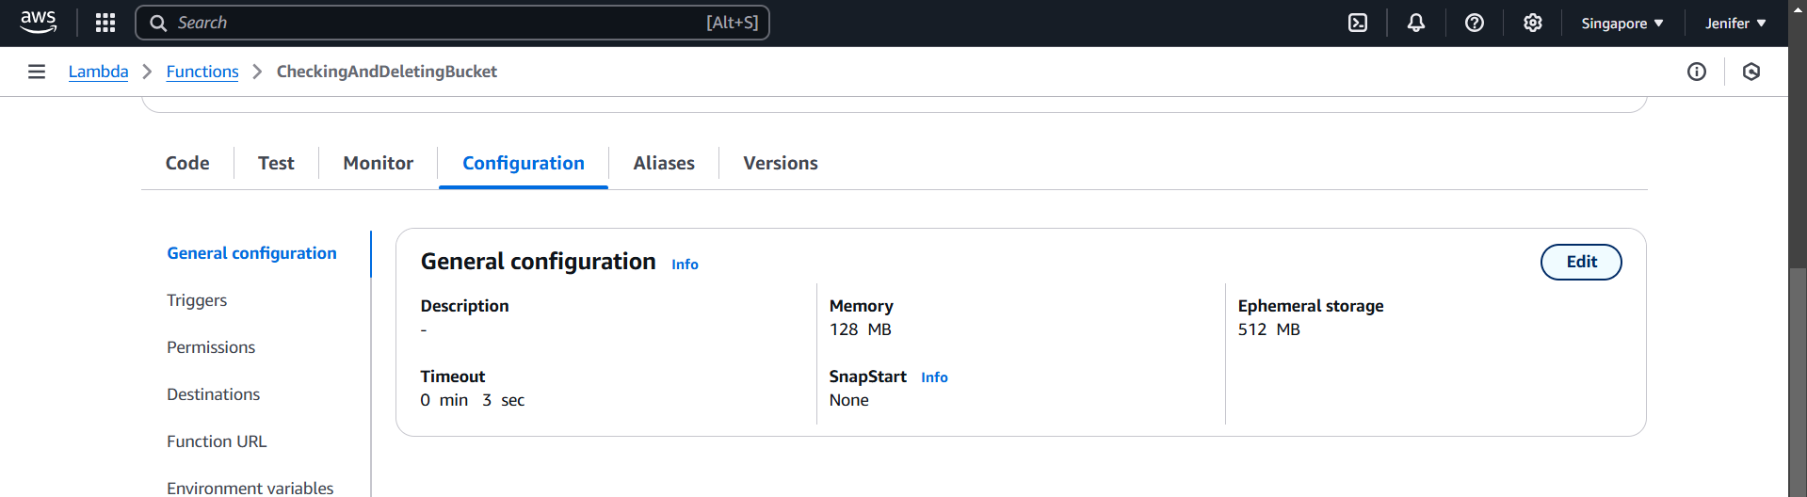

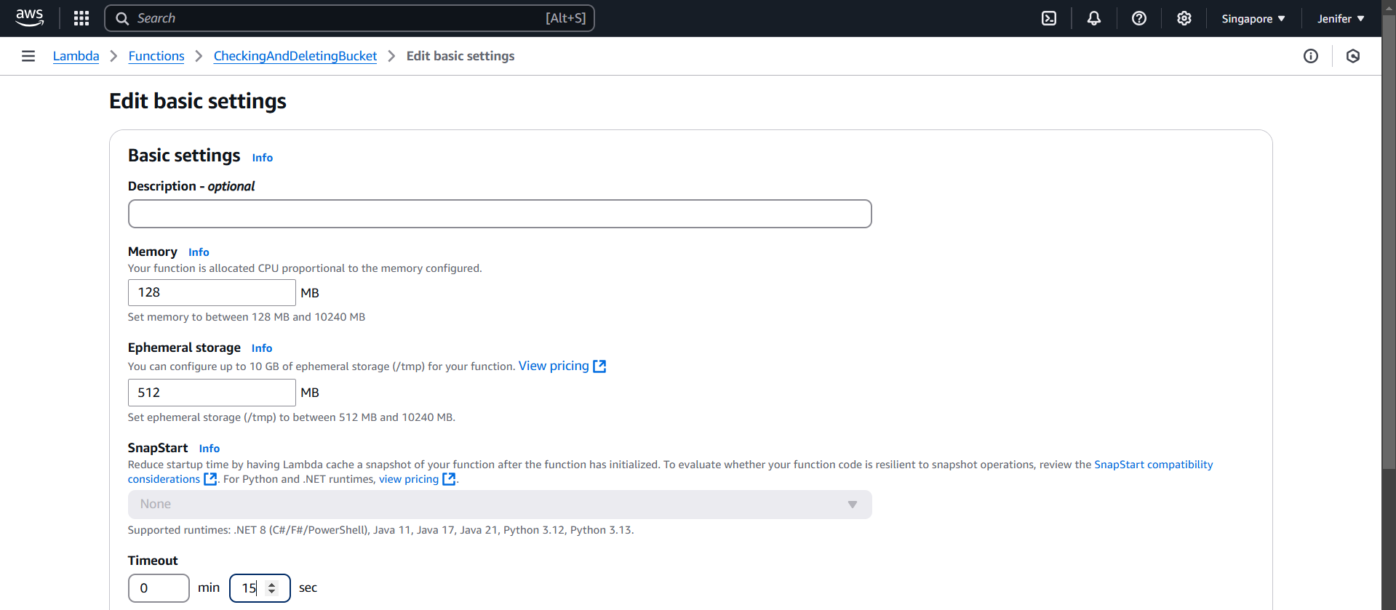

1. **The Code Tested Successfully and got the Outputs as follows**

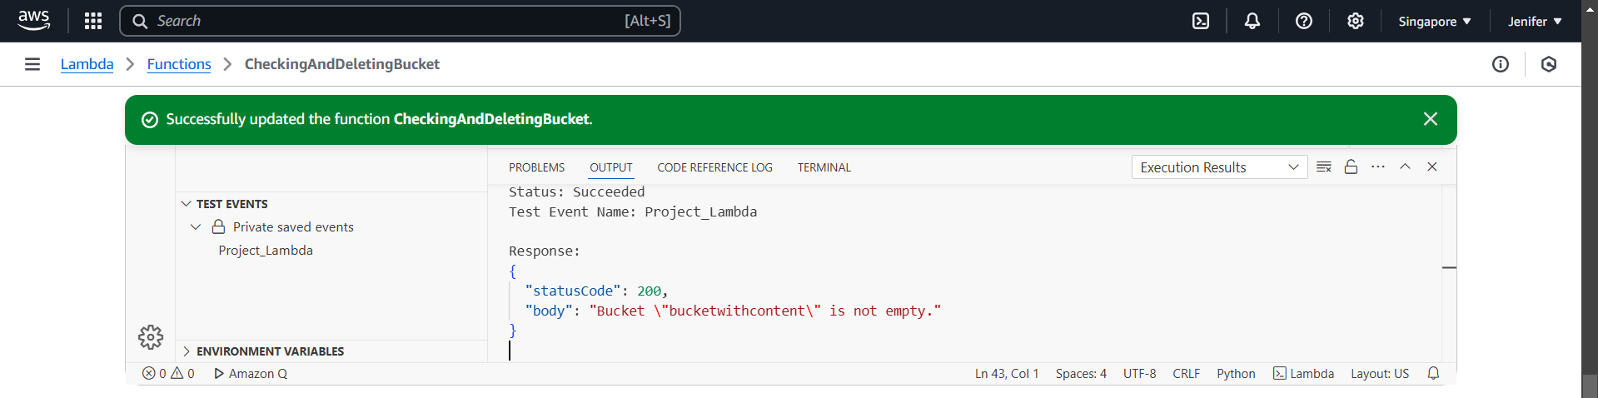

1. **In S3 Console all(3) the Empty Buckets got deleted successfully**

